

CAPSTONE PROJECT REPORT
Report 1 – Project Introduction

A2MaTeX - Android Device Automation and Distribution Platform

INSTRUCTOR: PHAM QUANG KHANG
CLASS: SEP490_G52
Team Members:
- Ly Ngoc Mai | HE190089
- Sy Thi Quynh Nga | HE190134
- Tran Tien Duc | HE180366
- Tran Xuan Dong | HE182253
- Tran Van Khuyen | HE187268

– Hanoi, Aug 2026 –
Table of Contents

Definitions & Acronyms 4
I. Record of Changes 5
II. Project Introduction 5
- Project Overview 4
1.1 Project Information 4
1.2 Project Purpose 4
1.3 Project Stakeholders 4
- Project Background 4
- Existing Solutions 4
3.1 EasyClick 4
3.2 Auto.js 4
3.3 AutomationMart 4
3.4 Section Summary 4
- Proposed Solution 4
- Project Scope & Limitations 4
5.1 Major Features 4
5.2 Limitations & Exclusions 4
List of Figures
Figure No. | Title | Page
Figure 1
Figure 2
Figure 3
Figure 4
Table 1 - List of Figures
List of Tables
Table No. | Title | Page
Table 1 | List of Figures | 3
Table 2 | List of Tables | 3
Table 3 | Definitions & Acronyms | 4
Table 4 | Record of Changes | 5
Table 5 | Assumptions & Constraints | 6
Table 6 |  | 9
Table 7 |  | 9
Table 8 |  | 9
Table 9 |  | 10
Table 10 |  | 13
Table 11 |  | 13
Table 12 |  | 14
Table 13 |  | 16
Table 14 |  | 17
Table 15 |  | 18
Table 2 - List of Tables

Definitions & Acronyms
No | Acronyms & Abbreviations | Definition
1 | A2MaTeX | Android Automation Marketplace Technology
2 | UI | User Interface
3 | IDE | Integrated Development Environment
4 | API | Application Programming Interface
5 | QA | Quality Assurance
6 | AI/ML | Artificial Intelligence / Machine Learning
7 | GAP | A limitation or unmet need identified in an existing solution, which this project aims to address
8 | FE | Feature (as used in the Major Features table, e.g. FE-01)
9 | LI | Limitation/Exclusion (as used in the Limitations & Exclusions table, e.g. LI-01)
10 | SePay | A Vietnamese payment gateway used for processing transactions in the Workflow Marketplace
Table 3 - Definitions & Acronyms

I. Record of Changes
Date | A*  M, D | In charge | Change Description
20/09/2026 | A | KhuyenTV | Init document
22/09/2026 | A | NgaSTQ | Add existing solutions
*A - Added M - Modified D - Deleted
Table 4 - Record of Changes

I. Project Overview

1. Project Information
- English name: A2MaTeX - Android Device Automation Development and Distribution Platform
- Vietnamese name: A2MaTeX - Nền tảng phát triển và phân phối công cụ tự động hoá thiết bị Android
- Project code: A2MaTeX
- Group name: SEP490_G52
- Software type: Window Application & Web Application

2. Project Purpose
The purpose of this project is to develop A2MaTeX - Android Device Automation Development and Distribution Platform. A2MaTeX is designed to provide a centralized platform for creating, managing, and executing automation workflows on Android devices. The platform enables users to visually design automation workflows through a node-based interface, interact with Android applications, and distribute workflows to connected devices for execution. It also provides tools for monitoring and managing the execution of automation tasks. This document is intended to serve as a guideline and define the objectives and requirements for the implementation of the system and its core functions.

3. Project Stakeholders
Full Name | Role | Email | Mobile
Pham Quang Khang | Lecturer | khangpq3@fe.edu.vn
Ly Ngoc Mai | Leader | mailyngoc2301@gmail.com | 0968666975
Sy Thi Quynh Nga | Member | houselily010@gmail.com | 0833803102
Tran Tien Duc | Member | ductthe180366@fpt.edu.vn | 0886672025
Tran Xuan Dong | Member | dongtxhe182253@fpt.edu.vn | 0343560382
Tran Van Khuyen | Member | khuyentvhe187268@fpt.edu.vn | 0918707142
Table 5 - Project Stakeholders

II. Product Background
Android devices are widely used in both personal and professional environments, and many activities require users to repeatedly perform the same sequence of actions. Tasks such as opening applications, navigating between screens, entering information, processing data, or checking results may seem simple individually, but performing them repeatedly can consume a considerable amount of time and effort. Repetitive manual work can also lead to human errors and inconsistent results.
The challenge becomes more significant when the same workflow needs to be executed frequently or across multiple Android devices. Users may need to repeat the same actions on each device, manually transfer scripts, or maintain different automation solutions for different tasks. As the number of workflows and devices increases, managing these processes becomes increasingly difficult and inefficient.
Although Android automation is commonly associated with software testing, its applications extend to many other areas, including business operations, data processing, device management, personal productivity, and other repetitive workflows. However, creating and managing automation workflows can still require technical knowledge and significant effort.
Therefore, there is a need for a flexible platform that can support different Android automation scenarios instead of focusing on a single use case. A2MaTeX is designed to provide a centralized environment for creating, managing, executing, and distributing reusable automation workflows across Android devices, helping users reduce repetitive manual work and manage automation more efficiently.

III. Existing Solutions

1. EasyClick
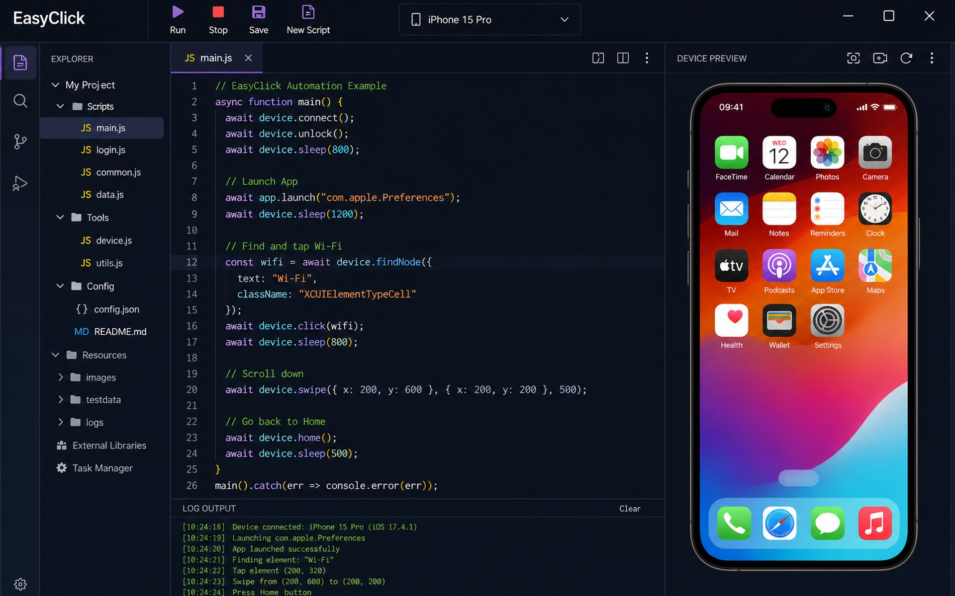
Figure 1: EasyClick
EasyClick is an Android automation platform developed by the EasyClick team, designed to automate tasks on Android devices through scripting and visual development tools. Users can create automation scripts, interact with mobile app interfaces, and execute automated workflows on connected devices.
Website / Link | EasyClick - Android / iOS / HarmonyOS Next Mobile Automation & AI Agents
Target Users | Android users, developers, and automation enthusiasts who want to automate repetitive tasks or build custom mobile automation tools.
Core Features | Visual automation development, JavaScript scripting, Android UI interaction, automated task execution, and script packaging.
Strengths | Combines scripting flexibility with visual development tools; enables users to create customized automation workflows and automate interactions with Android applications.
Weaknesses | Advanced automation may require programming knowledge; scripts may require maintenance when app interfaces or Android environments change.
GAP for this project | EasyClick provides Android automation development and execution capabilities, but the project aims to go further by integrating a marketplace for third-party automation tools, time-limited licenses, and a centralized desktop client for managing and executing purchased tools. Its workflow also emphasizes a dedicated no-code IDE for creating and distributing marketplace products.

2. Auto.js
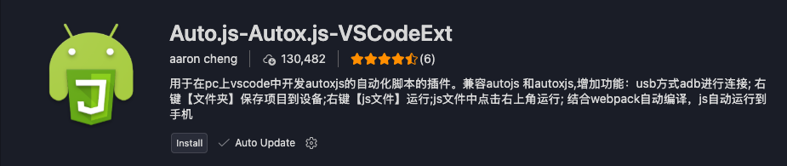
Figure 2: Auto.js
Auto.js is an Android automation tool that enables users to write JavaScript scripts to automate actions on their devices. It is used to interact with app interfaces, perform repetitive tasks, and build custom automation workflows, primarily by users with programming knowledge.
Website / Link | openautojs/openautojs
Target Users | Android users, developers, and automation enthusiasts who want to automate repetitive tasks using JavaScript.
Core Features | JavaScript-based scripting, UI interaction, task automation, and custom automation workflows on Android devices.
Strengths | Flexible and customizable; allows users to create complex automation logic and reuse scripts for repetitive tasks.
Weaknesses | Requires programming knowledge for advanced use; users may need to handle script maintenance, compatibility, and distribution themselves.
GAP for this project | Auto.js primarily focuses on creating and running automation scripts rather than providing an integrated marketplace. It does not, as a core offering, combine time-limited tool licensing, a centralized desktop client, and a no-code IDE for creating and distributing commercial Android automation tools.

3. AutomationMart
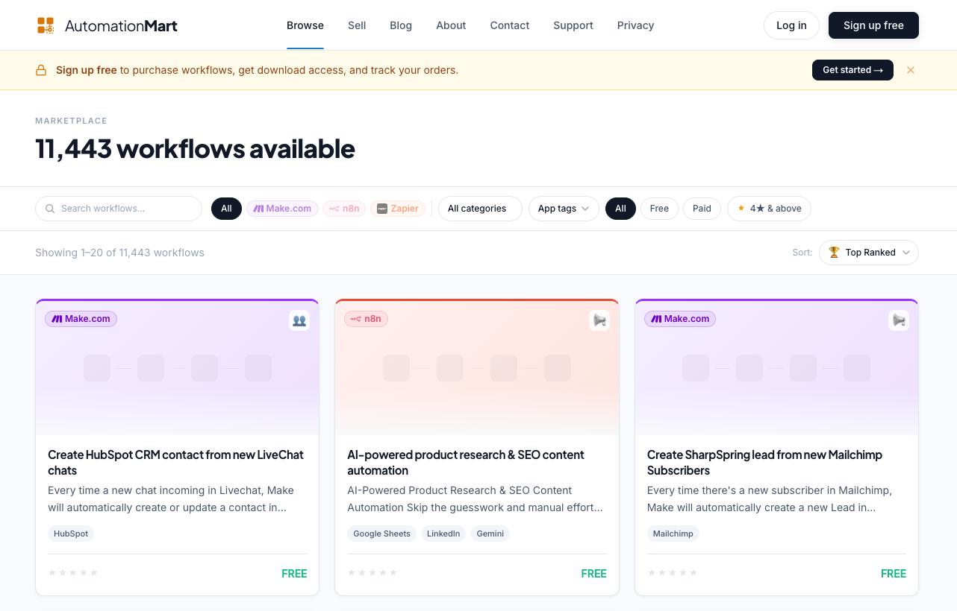
Figure 3: AutomationMart
AutomationMart is an online marketplace for discovering and purchasing ready-made automation workflows, including those built for platforms such as Make.com, n8n, and Zapier. It connects automation creators with users who can purchase and reuse existing workflows rather than building them from scratch.
Website / Link | AutomationMart - Every automation. Ready to deploy.
Target Users | Automation creators, businesses, and individuals looking to purchase or reuse ready-made automation workflows.
Core Features | Marketplace for discovering, purchasing, and sharing automation workflows, including workflows for platforms such as Make.com, n8n, and Zapier.
Strengths | Helps users save development time by providing reusable workflows; offers creators a channel to distribute and monetize their automation solutions.
Weaknesses | Focuses on workflow marketplaces rather than Android-specific automation; workflows may require compatible platforms and additional configuration to use.
GAP for this project | AutomationMart focuses on distributing workflows rather than providing an integrated Android automation ecosystem. It does not appear to offer the specific combination of an Android-focused no-code IDE, a desktop client for executing purchased tools, and centralized time-limited licensing that this project aims to provide.

4. Section Summary
Overall, Auto.js and EasyClick provide Android automation development and execution capabilities, while AutomationMart enables users to discover and purchase reusable workflows. However, none fully addresses the need for an integrated Android-focused ecosystem combining a no-code IDE, a marketplace for third-party automation tools, time-limited licensing, and a centralized desktop client for managing and executing purchased tools. Our proposed product aims to bridge this gap by bringing automation creation, distribution, and execution together in one platform.

IV. Proposed Solution
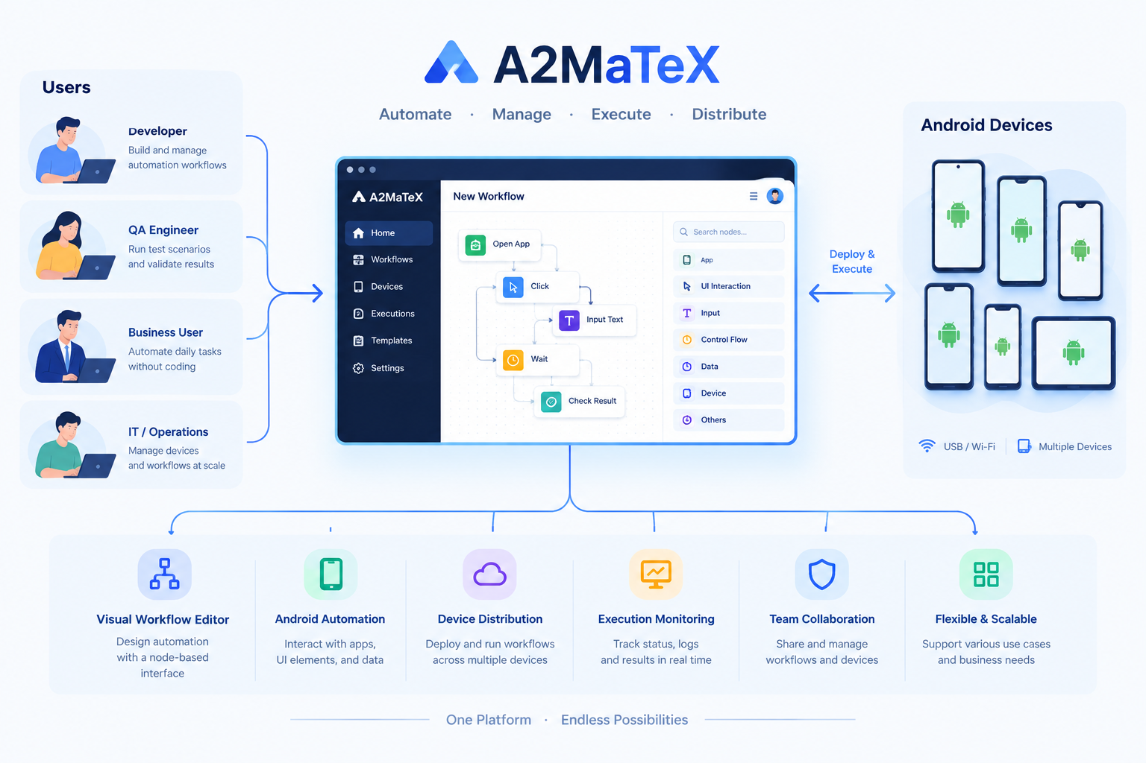
Figure 4: Proposed Solution

A2MaTeX is a centralized platform that lets users design, manage, execute, and distribute automation workflows across multiple Android devices, instead of building and maintaining separate, ad-hoc automation scripts for each device or task. Rather than writing scripts by hand or repeating the same actions manually on every device, users design a workflow once through a visual, node-based interface, then distribute and run it simultaneously across connected devices. This directly addresses the gap left by current approaches (manual operation, one-off scripts per use case, or automation tools built for a single purpose such as software testing): the lack of a shared, reusable, and extensible environment that supports different automation scenarios.
The direct beneficiaries are users and organizations that need to perform repetitive Android tasks frequently or across a large number of devices - for example, operations staff who need to run bulk checks or data entry, QA teams that need to re-run the same test scenario on many devices, or individuals who want to automate routine tasks on their own phones. With A2MaTeX, these users don't need deep programming knowledge to build automation (thanks to the drag-and-drop, node-based interface), can monitor execution progress in real time, and can reuse the same workflow across multiple devices instead of manually repeating the effort on each one - reducing time spent on manual work, lowering human error, and making it easier to scale as the number of devices and workflows grows.
This is the right time and the right approach because demand for Android automation has expanded well beyond software testing into business operations, data processing, device management, and personal productivity, while most existing tools are still built for a narrow technical audience (QA/testers) or require writing code. Building a platform that is at once visual (no coding required), centralized (managing many devices and workflows in one place), and flexible (not tied to a single use case) is the right direction to close this gap, rather than continuing to maintain many separate, purpose-built automation tools for each individual need.

V. Project Scope & Limitations

1. Major Features
ID | Feature Name | Description
FE-01 | Visual Workflow Builder | Users design automation workflows through a drag-and-drop, node-based interface, without writing code, combining actions (open app, tap, input data, wait, conditions...) into a complete workflow.
FE-02 | Device Connection & Management | Connect, pair, and manage a list of Android devices from a centralized interface, tracking each device's connection status (online/offline).
FE-03 | Workflow Distribution | Distribute a single designed workflow to multiple selected devices, allowing simultaneous execution without re-configuring from scratch on each one.
FE-04 | Execution Monitoring & Logging | Track workflow execution progress in real time on each device, logging results, errors, and completion status for each step.
FE-05 | Workflow Library Management | Store, edit, duplicate, and reuse created workflows, organized into a personal library for reuse across different devices/projects.
FE-06 | Workflow Marketplace | A platform that lets developers publish created workflows (with version management, descriptions, and changelogs); other users can browse, view details, and purchase workflows to download into their personal library.

FE-06 sub-features:
ID | Feature Name | Description
FE-06-SUB-01 | Developer Publishing | Developers package a workflow, set its name, description, and price, and publish it to the marketplace.
FE-06-SUB-02 | Version Management | Each workflow can have multiple versions; users can view the changelog and choose to update or keep an older version.
FE-06-SUB-03 | Browse & Purchase | Users browse the list of workflows, view details, and purchase to download into their personal library (FE-05).
FE-06-SUB-04 | Payment Processing | Handles payment when a workflow is purchased (via a mock/sandbox payment flow - see LI-04).
FE-06-SUB-05 | Revenue Sharing | Automatically calculates and records each developer's share of revenue from workflow sales, based on a defined split ratio.

2. Limitations & Exclusions
ID | Excluded Item | Reason
LI-01 | iOS platform support | v1 focuses only on Android, the most relevant platform for automation within this project's scope; iOS support is constrained by OS-level security restrictions and will be reassessed in a later version.
LI-02 | AI/ML-assisted workflow suggestions | Suggesting or auto-generating workflows via AI requires training data and model integration outside the scope of v1; will be considered once sufficient real usage data has been collected.
LI-03 | Public rating/review system for marketplace workflows | v1 only supports browse, purchase, and versioning; public ratings and reviews are deferred to a later version.
LI-04 | Developer payout / withdrawal to bank account | Revenue share is calculated and recorded in v1, but actual payout/withdrawal to developers' bank accounts requires additional financial/legal processing and is deferred to v2.
LI-05 | Refunds and transaction disputes | Handling refund requests and disputes involves complex business and legal processes, deferred to a later version.
LI-06 | Advanced reporting/analytics dashboard | v1 only provides basic execution logs; aggregated reports and performance charts over time will be added once enough usage data has been collected.
LI-07 | Multi-language support | v1 supports a single interface language only; multi-language support will be considered based on user feedback after initial rollout.

